**Database**

1. Create Table : Student and Exam

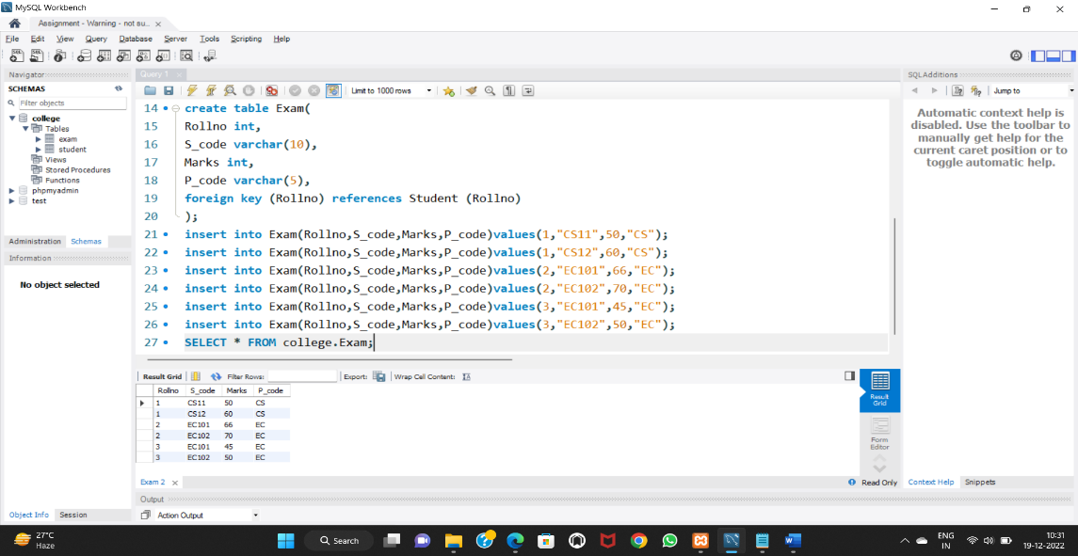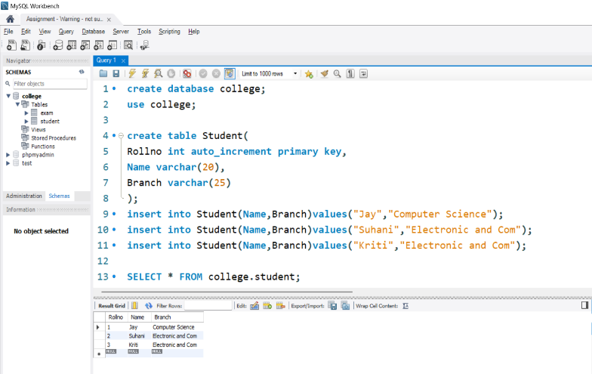

2. Create Table.

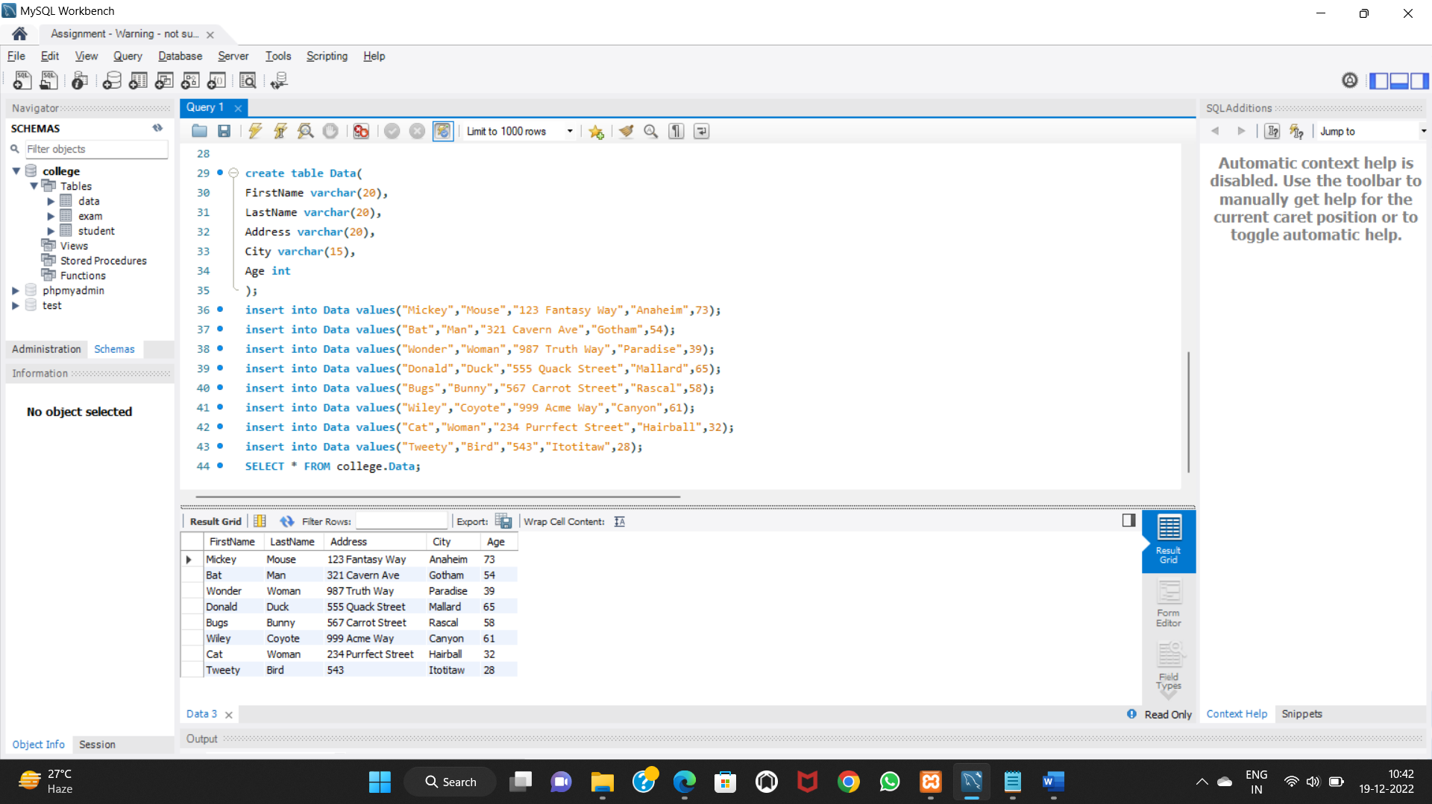

3. Create Table : Employee and Incentive

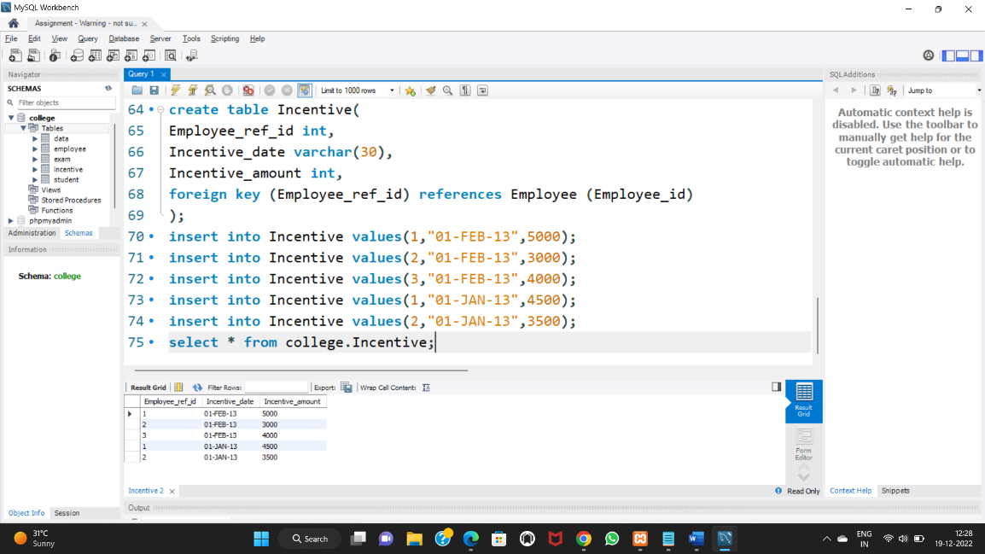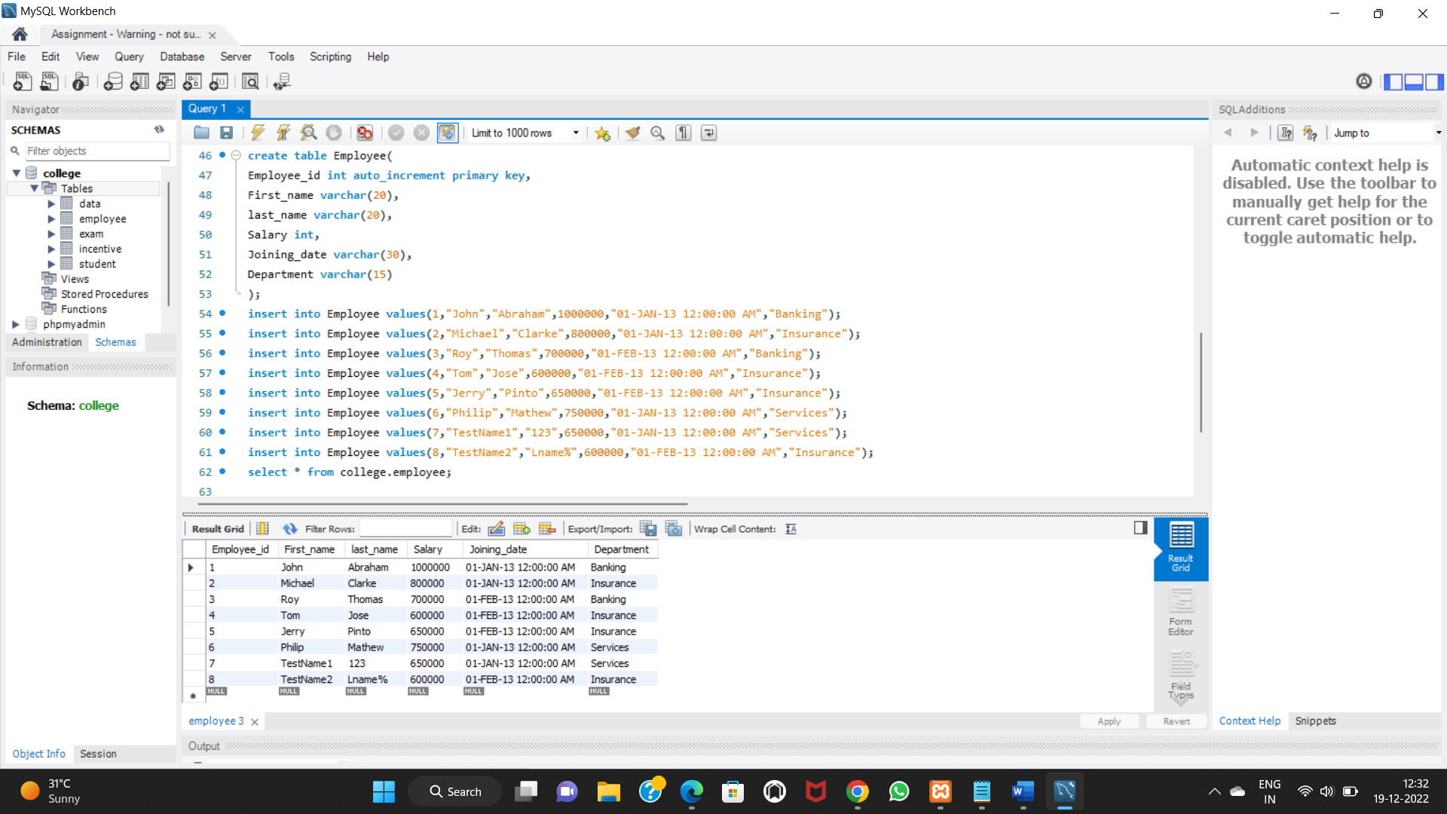

1. Get First_Name from employee table using Tom name “Employee Name”.

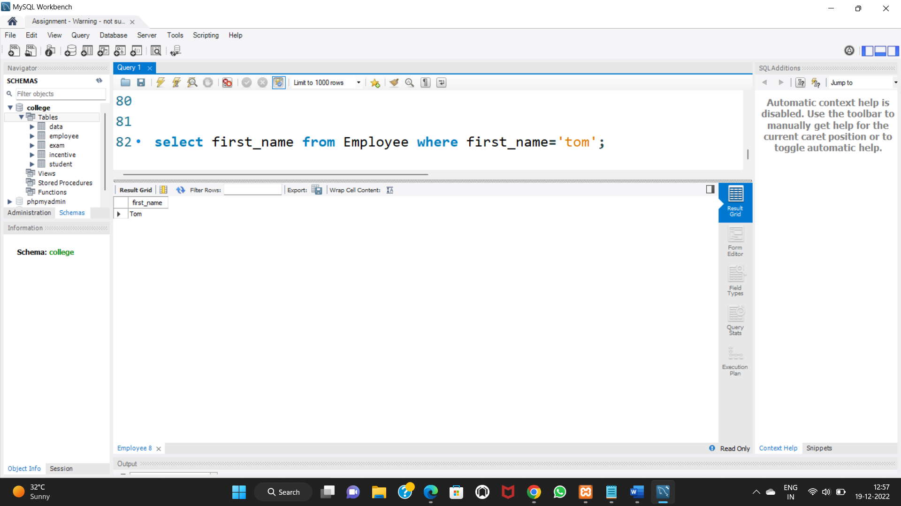

1. Get FIRST_NAME, Joining Date, and Salary from employee table.

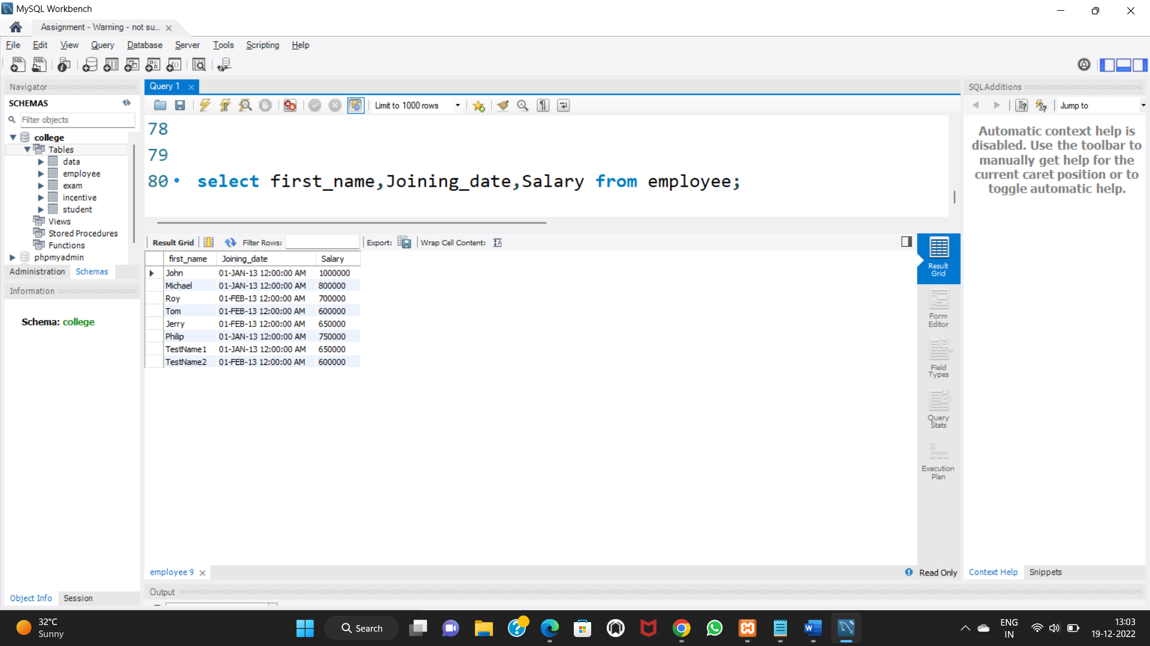

1. Get all employee details from the employee table order by First_Name Ascending and Salary descending?

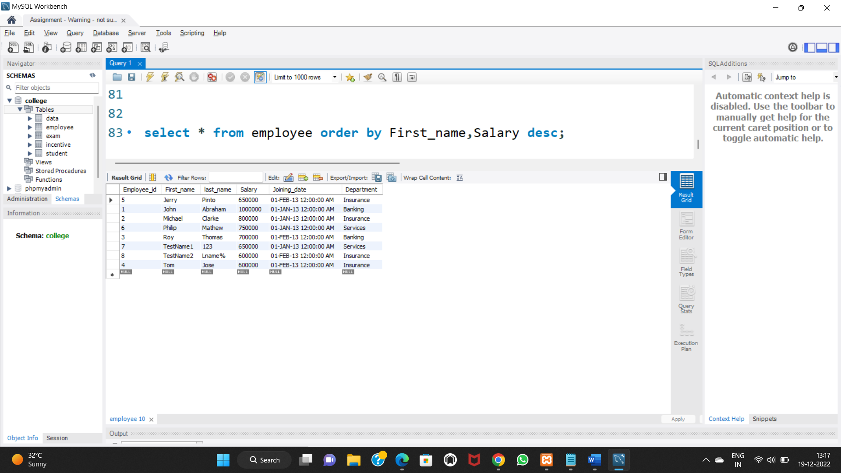

1. Get employee details from employee table whose first name contains ‘J’.

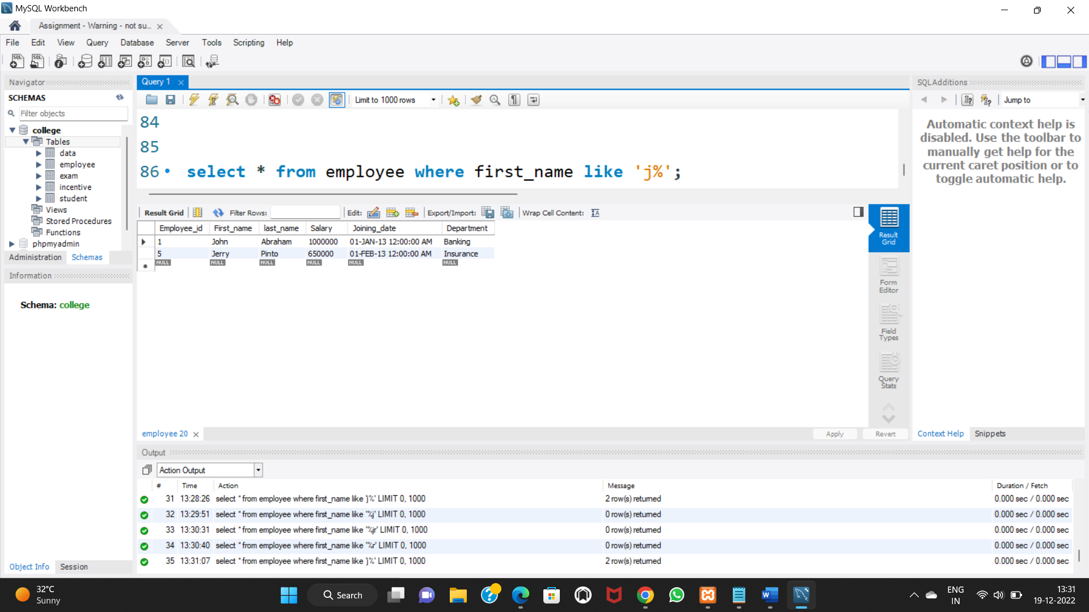

1. Get department wise maximum salary from employee table order by salary ascending?

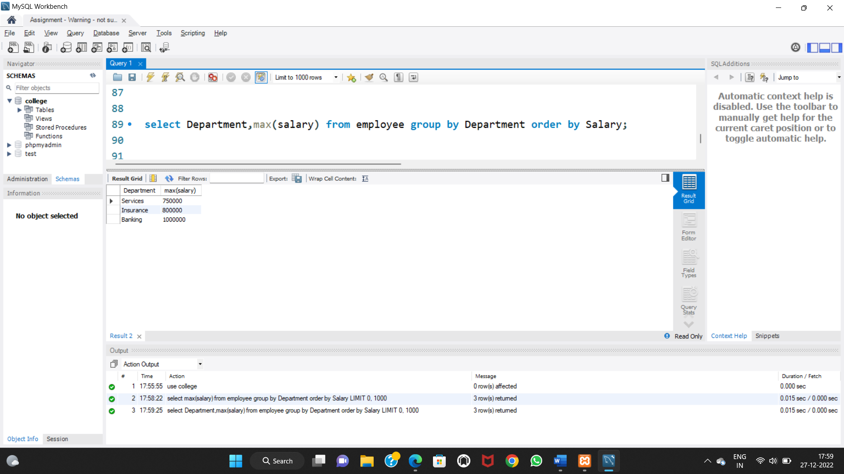

1. Select first_name, incentive amount from employee and incentives table for those employees who have incentives and incentive amount greater than 3000

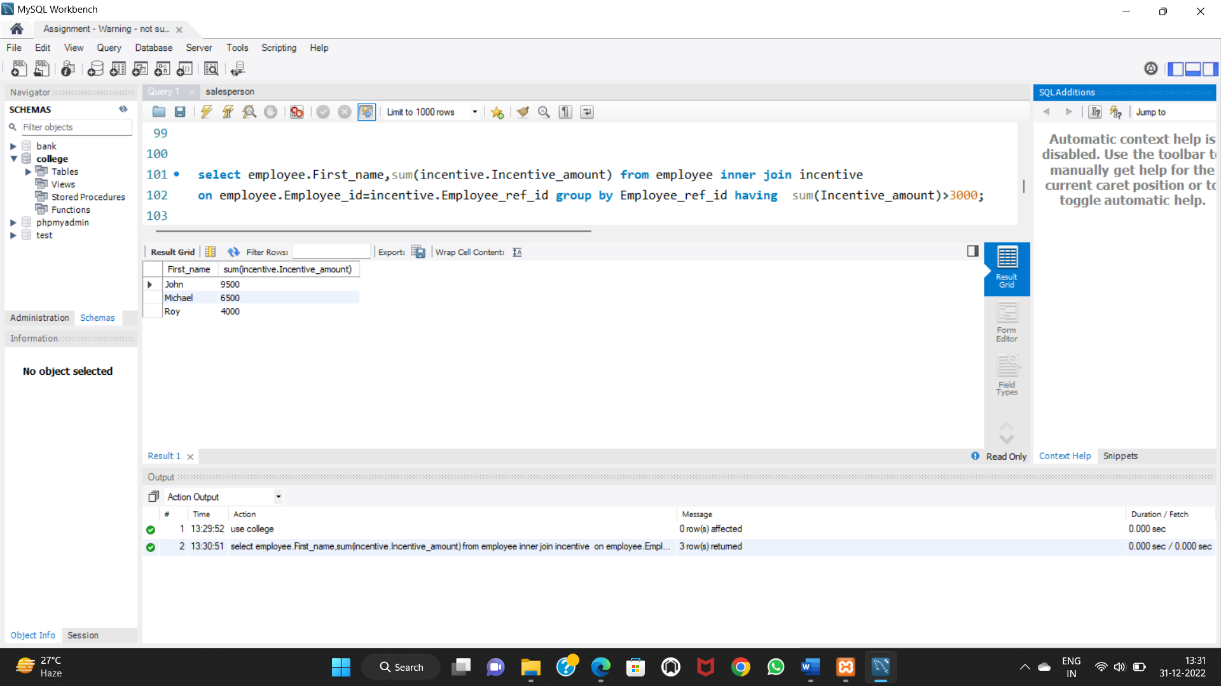

1. Create After Insert trigger on Employee table which insert records in view table

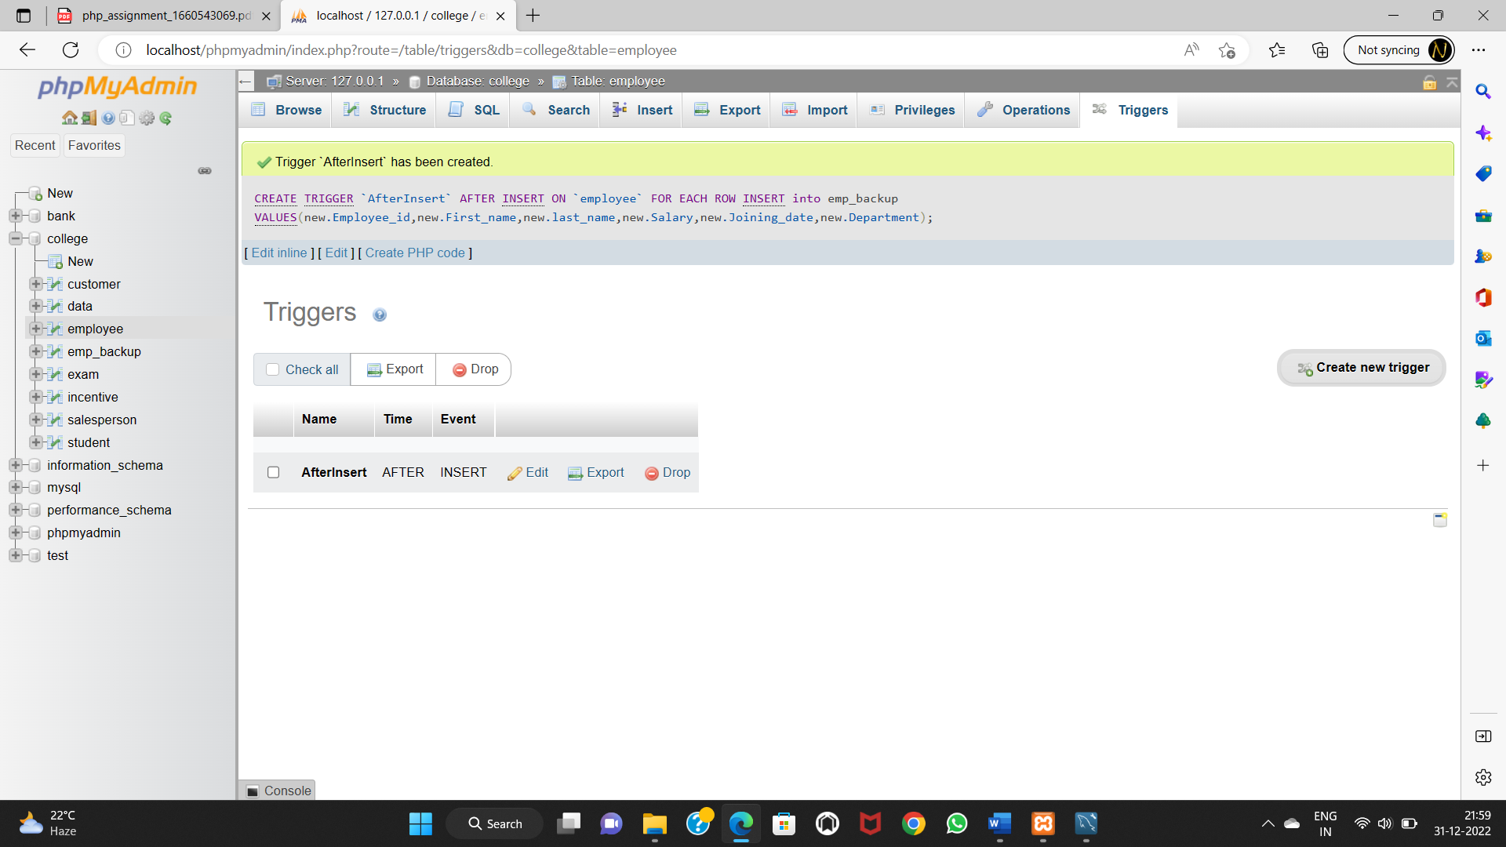

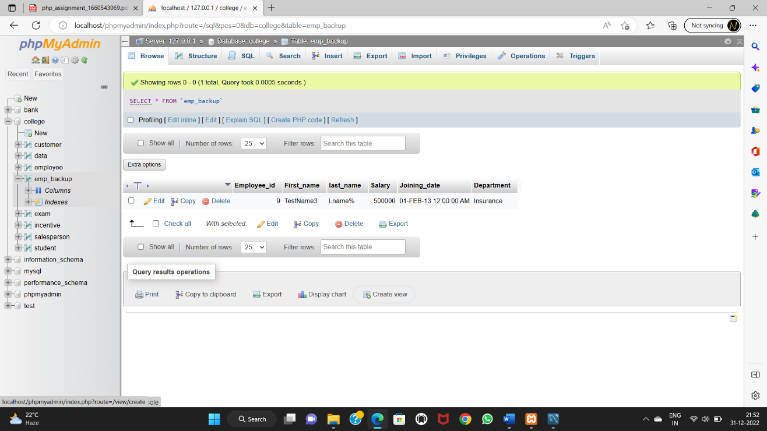

4. Create table : Salesperson and Customer

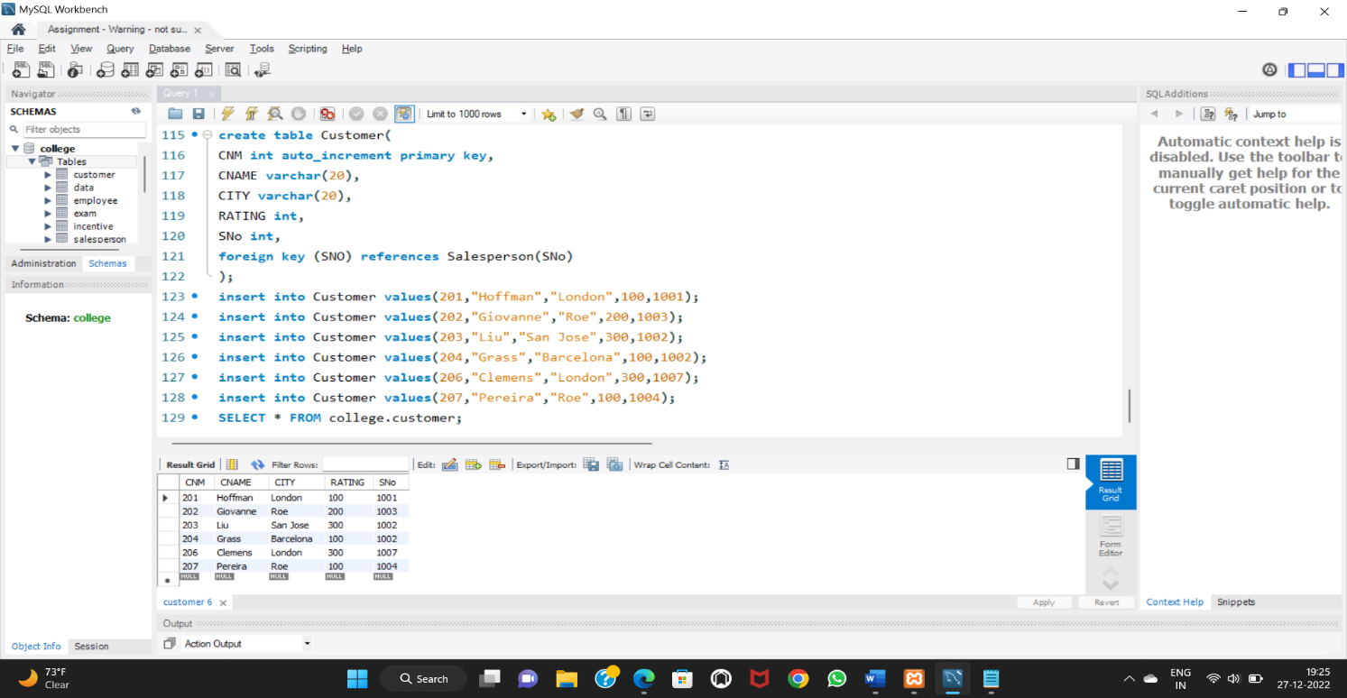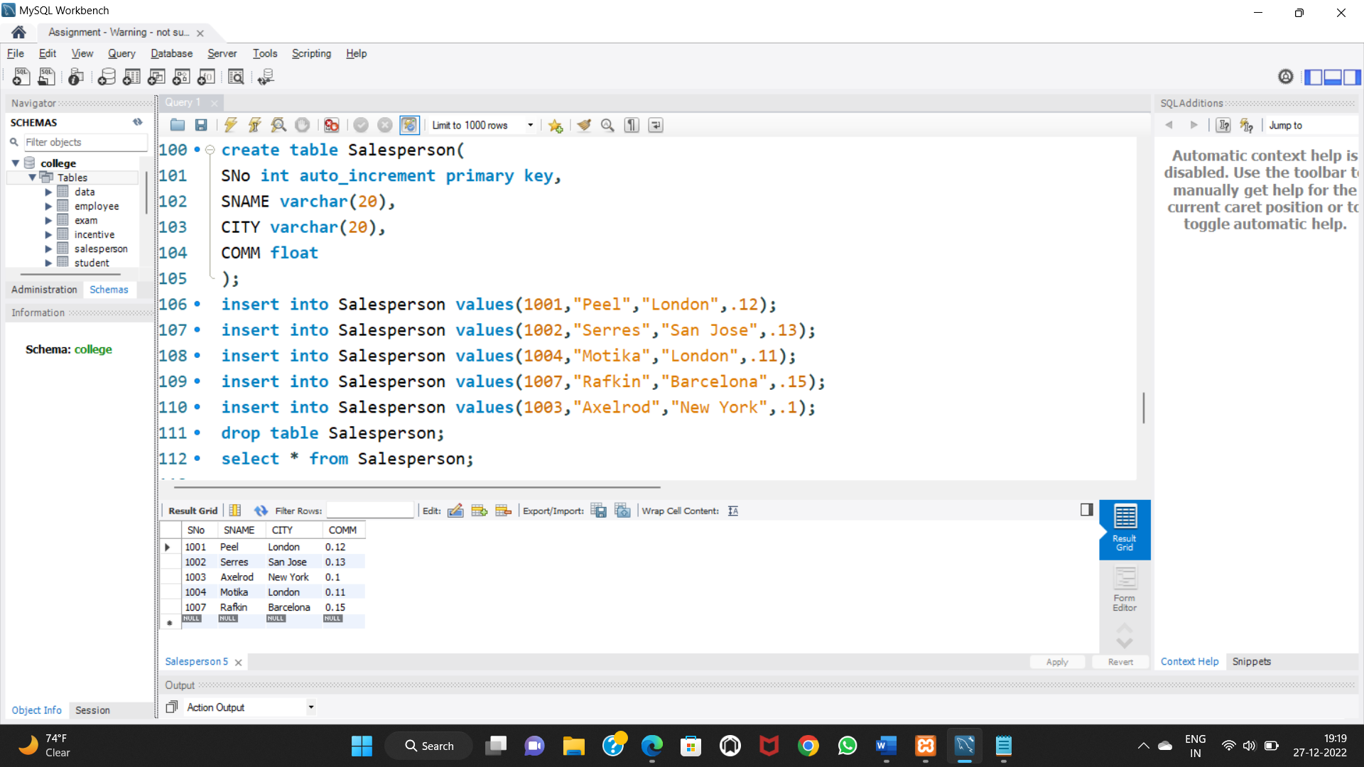

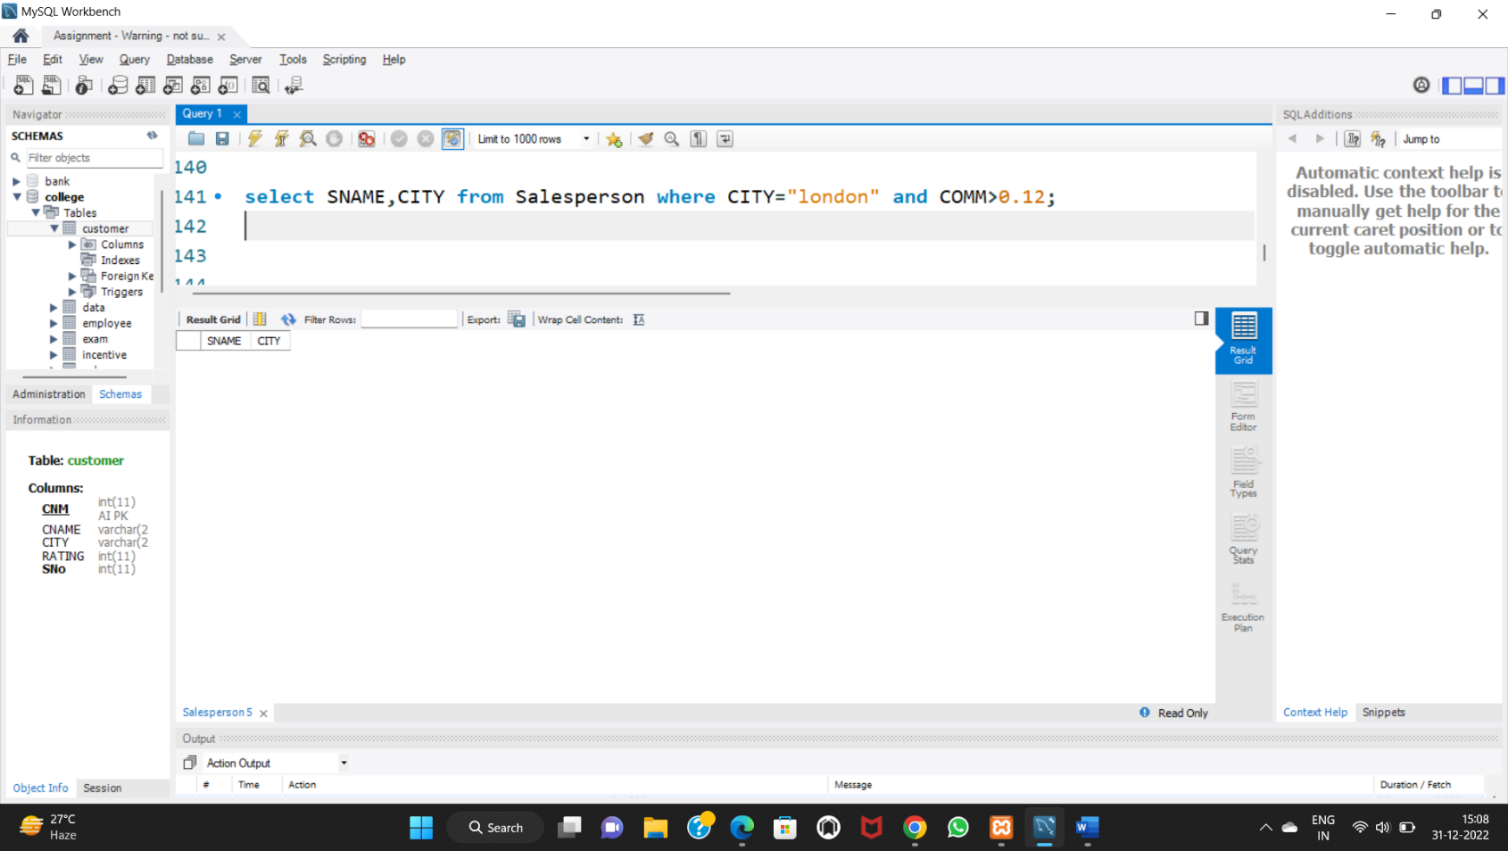b) Names and cities of all salespeople in London with commission above 0.12

c) All salespeople either in Barcelona or in London

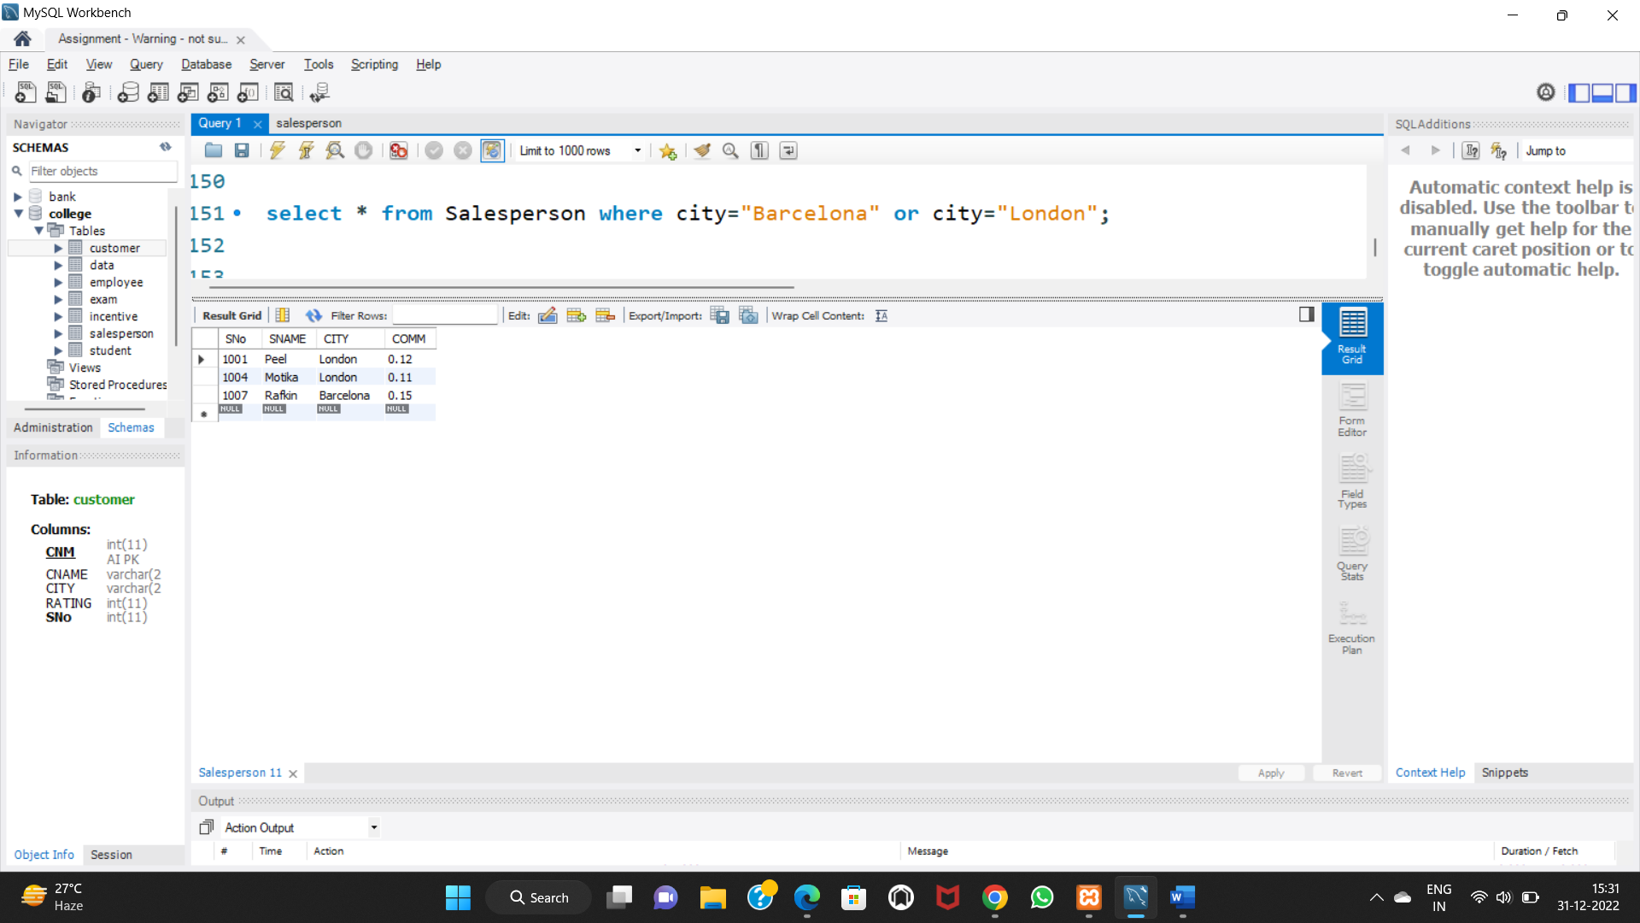

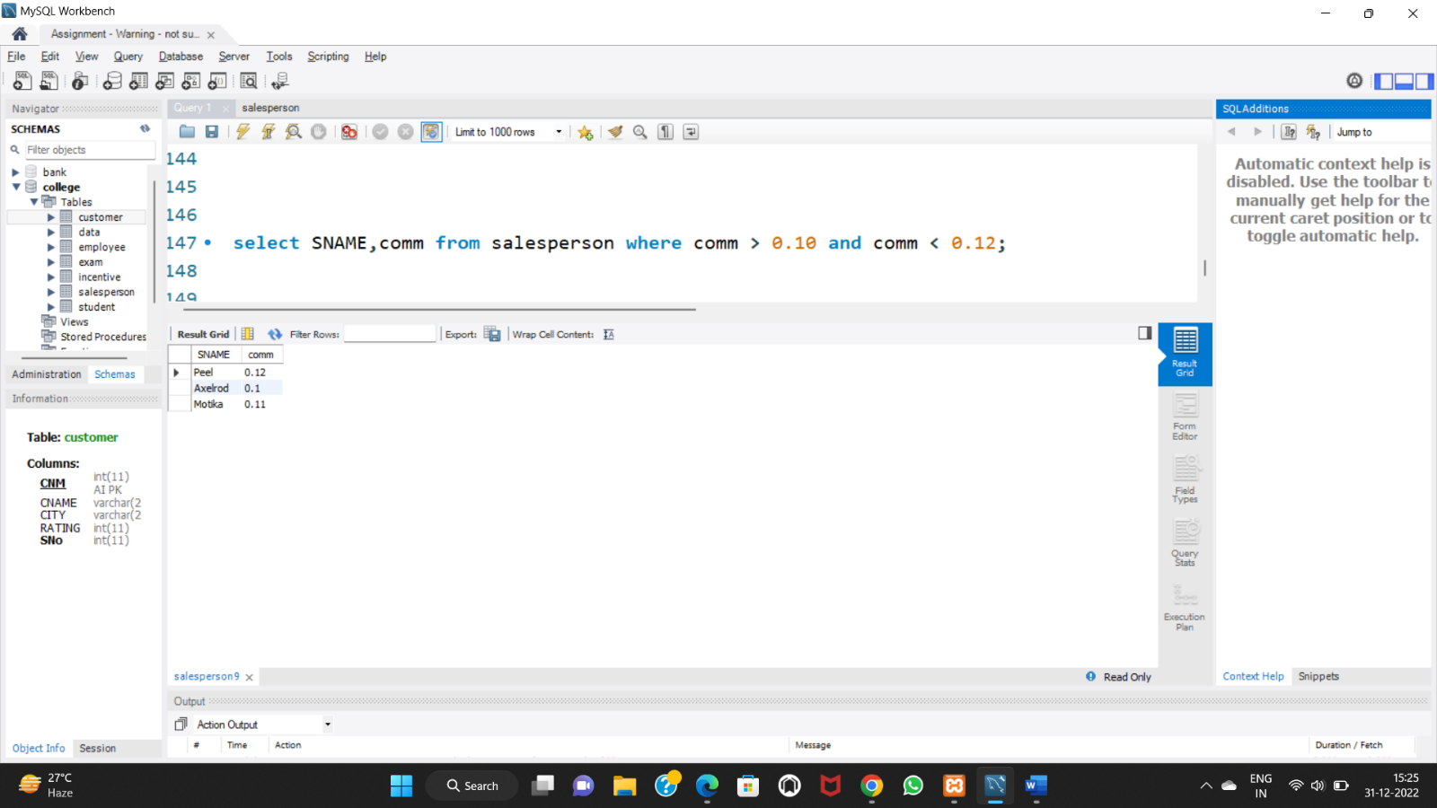d) All salespeople with commission between 0.10 and 0.12. (Boundary values should be excluded).

e) All customers excluding those with rating <= 100 unless they are located in Rome

